Hockey Canada
High Performance 1
Leadership Techniques in Coaching:
Additional Coaching Resource Material
Version 1.0

The Collection, Use, and Disclosure of Personal Information
The Coaching Association of Canada collects your NCCP qualifications and personal information and shares it with all NCCP partners according to the privacy policy detailed at www.coach.ca. By participating in the NCCP you are providing consent for your information to be gathered and shared as detailed in the privacy policy. If you have any questions or would like to abstain from participating in the NCCP please contact coach@coach.ca.

Character is the Key

C – commitment
H – honesty
A – accountability
R - respect
A – attitude
C – courage
T – trust
E – ethics & integrity
R – responsibility

The 5 A’s of Leadership

- Approachable
- Accepting
- Acknowledging
- Accountable
- Adaptable

- Leading with Purpose

I know of no more encouraging fact then the unquestionable ability of a man/ woman to elevate his/her life by conscious endeavor
- H.D. Thoreau

- Leading with passion requires that you lead with clarity and purpose, the simple elegance of meaning. Purpose begins with intention, meaning and context.

Why are you coaching?

- Leading with Vision

“The leader must be deliberate and vigilant eliminating barriers and obstacles, giving people a keen line of site.”

- Leading with a clear and compelling vision helps align team members with a sense of direction and focus. It gives the team something to aim at, something to make happen and something to manifest into positive results.

What is your vision?

- Leading with Heart

“There is no limit to the heart. Its energy is universal. Time and time again it empowers us to manifest purpose and vision into extraordinary results.”

- Leaders who make the greatest difference do it with heart.

Is your heart in your coaching?

Are you running at full tank of energy?

Do you lead with heart?

Is this reflected in the people you surround yourself with?

- Leading with Attention

The attentive, passionate leader knows that it is not just what I say to people, but how I sound when I say it and what I look like when I say it that has the most impact. | Inspiring leaders pay attention to impact and the connection we all share. Leading with passion requires paying attention to what matters most.

“The devil is in the details”. If you are not grounded in reality with good data, facts, information and feedback, we can easily misfire.

How do you know your roadmap?

What is your baseline for assessment?

- Leading with Integrity

- Authentic teamwork requires trust, a cornerstone to any healthy relationship. Integrity builds trust, within one’s self and within one another.

How do you demonstrate integrity?

What makes you a role model coach?

- Leading with Discipline

Are you a discipline of action?
When it comes to walking your talk, do you walk with responsibility and accountability?
Do you execute your intentions with attention?

- Leading with discipline requires setting goals and establishing measurement. Without access to the score, you lose the means to accurately measure performance against standards and evaluate progress.

How do you establish goals and how do you measure progress?

- Leading with Generosity

“It is one of the most beautiful compensations of life, that no man can sincerely try to help another without helping himself.”
- R.W. Emerson

- You are born to generate and to generate. You must be generous.

What do you have to offer and how can you give more?

- Leading with Credibility

“We are what we repeatedly do. Excellence, then, is not an act but a habit.”
- Aristotle

Do your players and staff see you as a positive role model and mentor?
Do you practice what you preach and preach what you practice?

What evidence do you have to support your answers to the questions above?

- Leading with Grace

- Grace is fluid and dynamic, with no beginning and no end. It is always present, a frequency or vibration that plays continuously – even if we are not tuned into it.

Do you bow to the pressure or do you rise above it with grace?

What example do you set for your team?

- Leading with Spirit

“Our greatest glory is not in never failing but in rising up every time we fail.”
- R.W. Emerson

- Passionate leadership requires positive energy and positive energy flows from spirit.
- You can choose to react negatively with fear, attack, defense or retreat. Or you can choose to respond positively with hope, faith, optimism and creativity.

How do you ensure that you remain positive, attracting positive energy into solutions?

Pulling it all together

- Start with purpose to make sure you are doing what needs to be done
- Add a compelling vision to give people something clear and meaningful to focus on
- Mix purpose and vision with heart to bind with determination, courage and conviction
- Add a healthy amount of attention to be present and aware of the now
- Blend with integrity to build trust and demonstrate authenticity
- Bake with discipline to perform at optimal levels and be accountable for results
- Cover with generosity so that everyone gets a share
- Serve with credibility so that it tastes as sweet as it is
- Give thanks with grace for the abundance we have
- Enjoy with spirit and feed the soul.

Ten Steps to Overachieving

- Build Self-esteem |  | -
- Set Demanding Goals |  | -
- Always be positive |  | -
- Establish Good Habits |  | -
- Master the Art of Communication |  | -
- Learn from Role Models |  | -
- Thrive on Pressure |  | -
- Be Ferociously Persistent |  | -
- Learn from Adversity |  | -
 | Survive Success | -

Harassment
Comments, conduct or gestures that are insulting, intimidating, humiliating, malicious, degrading, offensive, or discriminatory, directed toward an individual or group of individuals. Unwanted, unsolicited, unwelcome attention or actions, which annoy another person.
Harassment can include:
- Condescending, patronizing, threatening or pushing actions which undermine self-esteem.
- Practical jokes which cause awkwardness or embarrassment, or which may endanger a person’s safety.
- Hazing, unwanted physical conduct.
- Retaliation for having raised a concern, filed a complaint, etc.

Child Abuse
Any form of physical, emotional, and/or sexual mistreatment or lack of care, which causes, physical injury or emotional damage to a child. A common characteristic of all forms of abuse against children and youth is an abuse of power, of authority and/or breach of trust.

Bullying
Bullying is intentionally hurting someone in order to insult, humiliate, degrade or exclude him or her.

Bullying can be broken down to four categories:
- Physical
- Verbal
- Relational (reject, exclude)
- Reactive (engaging and taunting)

Disclosures
There are two types of disclosures: Verbal Disclosures and Non-verbal disclosures. Regardless of how kids tell, disclosures are usually mixed with several strong emotions – relief, guilt, fear and chaos because now someone else knows the secret. Both types of disclosure need to be handled sensitively while following specific procedures.

Traits of Effective & Respected Leadership

- Excellent Communication Skills  - Trust Worthiness  - Willingness to Listen  - Confidence & Experience  - Good Attitude  - Accountability | - Ability to Motivate  - Integrity  - Encouragement Skills  - Ability to Stay Organized  - Ability to Inspire Respect

Coaching Musts!
- Respect for the game / sport
- Respect for the rules
- Respect for the officials
- Respect for the opposition
- Respect for teammates / coaches

HOCKEY CANADA MISSION STATEMENT:

Lead, Develop and Promote Positive Hockey Experiences.

Top Leadership Resources
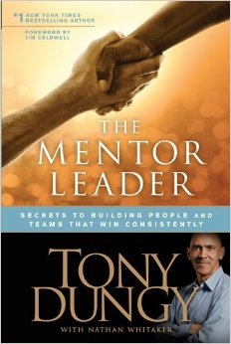 | 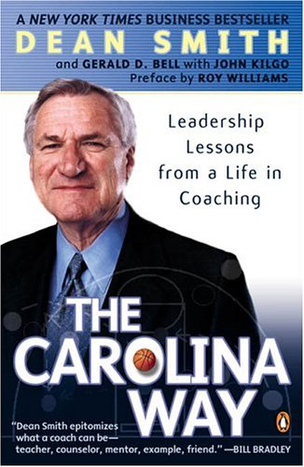
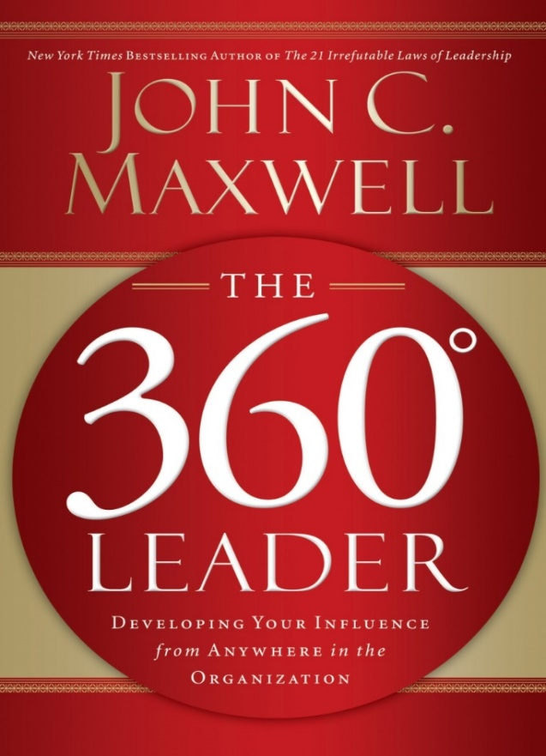
 | 